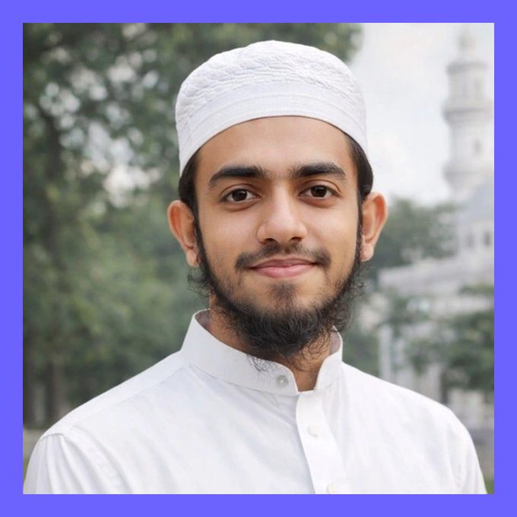    PORTFOLIO QR | MD SHAMIM MAHMUD  WordPress Developer • Local SEO Specialist • n8n Automation & AI Creative Professional  ✉ mdshamimmahmudbd@gmail.com 📞 +880 1590-026214 🌐 mdshamimmahmudbd.com/home/  📍 Bangladesh — Available for Local & International Projects ● AVAILABLE NOW

30+  PROJECTS & LIVE BUILDS | 5+  COUNTRIES SERVED | 39  SERVICE CAPABILITIES | 7+  CORE GROWTH CATEGORIES
PROFESSIONAL SUMMARY
Business-growth focused digital professional from Bangladesh specializing in WordPress development, WooCommerce/eCommerce, landing pages, Local SEO, lead generation, n8n automation and AI creative production. I help local and international businesses build stronger digital foundations — a professional website, clear search visibility, conversion-focused content, and connected automation systems that reduce manual work. My background combines structured WordPress training, an international internship in Malaysia, agency-level Figma-to-WordPress delivery, hands-on Local SEO experience, client/project management, lead-generation work and n8n automation training.
SELECTED RESULTS & BUSINESS VALUE
Delivered and contributed to 30+ website and digital projects across eCommerce, finance, education, study abroad, service business, SaaS/agency and personal brand categories — including public live links, direct development work and agency/client delivery contributions.

Website Development  WordPress, Elementor, WooCommerce, responsive business websites, landing pages and redesigns. | SEO & Visibility  Local SEO, AEO/GEO direction, on-page structure, content publishing, GBP/local visibility support. | eCommerce Systems  Product catalog, cart flow, category browsing and conversion-friendly store setup.

Lead & Automation  Lead collection, Gmail/email finding, directory research, n8n workflows and chatbot/automation thinking. | AI Creative Services  AI video, image creation, video ads, virtual models, voice AI agents, thumbnails, reels and banners. | Client Delivery  Briefing, coordination, project management, agency workflow and professional client communication.
PROFESSIONAL JOURNEY
From structured learning to international exposure, agency workflow, Local SEO internship, project management and automation training.
01 · Mexemy  WordPress Foundation Course | Structured WordPress learning that built the technical foundation for practical project delivery.
02 · Infinita Tech, Malaysia  Junior WordPress Developer Intern | Real-world WordPress workflow inside a Malaysian company — client-oriented delivery, responsive build standards and hands-on execution.
03 · Netherlands-Connected Agency  Figma to WordPress Specialist | Worked under a senior mentor and a Fiverr Level 1 seller on agency-level projects — pixel-perfect section implementation and professional delivery workflow.
04 · Local SEO Internship  Local SEO Intern — 4 Months | Deep practical exposure to Google presence, local visibility strategy, Google Business Profile/local signals and client-satisfaction-focused SEO work.
05 · Multimedia Gen  Client Manager → Project Manager | Developed client communication, project coordination, briefing, follow-up and delivery-management capabilities.
06 · Techlyft  Lead Generation — 2 Months | Worked on business development and lead generation, strengthening commercial understanding of client acquisition and outreach.
07 · Vibe Academy  n8n Automation Learning | Learned n8n automation foundations and workflow thinking for business-process automation, lead capture, CRM/data movement and reducing repetitive tasks.
08 · Client & Agency Projects  Professional Delivery Practice | Built and contributed to 30+ live websites, eCommerce stores, landing pages, education platforms, finance pages and agency/portfolio systems worldwide.
EDUCATION & LANGUAGE BACKGROUND
A concise academic background showing discipline, language exposure and formal Qawmi Madrasa board achievements alongside digital delivery, WordPress, SEO and automation work.
QAWMI MADRASA EDUCATION — BANGLADESH
Built a disciplined learning foundation with strong reading, memorization, communication and multilingual exposure. Board records show Mumtaz (distinction) division across key Qawmi Madrasa examination stages.
Verified Academic Records
YEAR | STAGE | DIVISION | TOTAL | NAT'L RANK | RESULT | INSTITUTION
2017 | Ibtidaiyyah | Mumtaz | 606 | 81 | View Result | Jamia Madania Baridhara, Dhaka
2019 | Mutawassitah | Mumtaz | 628 | 57 | View Result | Jamiyat Ibrahim (A.S.), Mahmudnagar, Demra, Dhaka
2022 | Thanawiyyah Ulya | Mumtaz | 612 | — | View Result | Jamiyat Ibrahim (A.S.), Mahmudnagar, Demra, Dhaka
Languages
Bangla  Native | English  Professional Working Proficiency | Hindi  Conversational | Urdu  Conversational | Arabic  Reading & Basic Communication
SKILLS SNAPSHOT
Core skill levels based on hands-on project delivery and client work.
WordPress Development |  | 90%
Elementor / Page Builders |  | 88%
WooCommerce / eCommerce |  | 82%
Figma to WordPress |  | 85%
Local SEO |  | 78%
n8n Automation |  | 72%
HTML / CSS / JavaScript |  | 80%
Client & Project Management |  | 85%
Website & WordPress
WordPress | Elementor | WooCommerce | Landing Pages
Business Websites | Website Redesign | Clone Website | Figma to WordPress
Responsive Design | Website Support
SEO & Growth
Local SEO | AEO / GEO | Backlink Strategy | Blog Publishing
Google Business Profile | Google Ads | Facebook Ads | Pixel Setup
Server-Side Tracking
Automation & Lead Systems
n8n Automation | Lead Generation | Gmail Finder | Directory Lead Collection
Email Marketing Automation | Messenger Chatbot | CRM Workflow Thinking
AI & Creative
AI Video Generation | AI Image Creation | AI Video Ads | Virtual Model
Voice AI Agent | Social Banner Generation | YouTube Thumbnail | Reels Editing
Tools & Workflow
Figma | HTML5 | CSS3 | JavaScript
jQuery | PHP Basics | Bootstrap | Tailwind
Git | Google Analytics | cPanel | Canva
CapCut AI
COMPLETE SERVICE DIRECTORY
39 client-focused service capabilities mapped from the live service dashboard — across WordPress, Digital Marketing, Lead Generation, Automation and AI Creative services.
WordPress & Website Development
# | SERVICE / CAPABILITY | CLIENT OUTCOME
01 | Any Kind of Website Development in WordPress | Build trust, structure & conversions
02 | Any Kind of Website Redesign in WordPress | Build trust, structure & conversions
03 | Clone Website in WordPress | Build trust, structure & conversions
04 | Ecommerce Website Development (WooCommerce) | Build trust, structure & conversions
05 | Landing Page Design | Build trust, structure & conversions
06 | Figma to WordPress Converter | Build trust, structure & conversions
07 | Ecommerce Product Listing | Build trust, structure & conversions
08 | Messenger Chatbot Setup & Automation | Build trust, structure & conversions
09 | WordPress Development Helper / Support | Build trust, structure & conversions
10 | AI-Based UI & UX Design + WordPress Development | Build trust, structure & conversions
11 | Elementor Expert | Build trust, structure & conversions
Digital Marketing & SEO
# | SERVICE / CAPABILITY | CLIENT OUTCOME
12 | Organic Social Media Growth | Grow visibility & demand
13 | Social Media Manager | Grow visibility & demand
14 | Monthly Content Writer | Grow visibility & demand
15 | Google Ads Publisher | Grow visibility & demand
16 | Facebook Ads Campaign Setup | Grow visibility & demand
17 | Pixel Setup with Server-Side Tracking | Grow visibility & demand
18 | Blog Writer & Blog Publisher | Grow visibility & demand
19 | Website Manager & Supporter | Grow visibility & demand
20 | Local SEO | Grow visibility & demand
21 | Backlink Provider | Grow visibility & demand
22 | AEO & GEO Service | Grow visibility & demand
23 | Website Product Promoter (Groups & FB Marketplace) | Grow visibility & demand
Lead Generation & Automation
# | SERVICE / CAPABILITY | CLIENT OUTCOME
24 | Any Kind of Lead Generation | Capture, organize & follow up leads
25 | Targeted Gmail Finder | Capture, organize & follow up leads
26 | Targeted Directory Site Lead Collection | Capture, organize & follow up leads
27 | Email Marketing Automation | Capture, organize & follow up leads
28 | n8n Automation | Capture, organize & follow up leads
AI Creative & Video Services
# | SERVICE / CAPABILITY | CLIENT OUTCOME
29 | AI Video Generation & Editing | Create scalable AI / video / social assets
30 | AI Image Creation & Editing | Create scalable AI / video / social assets
31 | AI Video Ads Creation | Create scalable AI / video / social assets
32 | Virtual Model Creation (AI) | Create scalable AI / video / social assets
33 | Voice AI Agent Creation | Create scalable AI / video / social assets
34 | AI-Focused Social Media Banner Creation | Create scalable AI / video / social assets
35 | Social Post Banner Generation | Create scalable AI / video / social assets
36 | Short Video Editing | Create scalable AI / video / social assets
37 | YouTube Thumbnail Creation | Create scalable AI / video / social assets
38 | Product Video Editing | Create scalable AI / video / social assets
39 | YouTube & Reels Video Editing | Create scalable AI / video / social assets

PROJECT PORTFOLIO
Live projects and direct development work across business, eCommerce, finance, education, service, SaaS and agency sites.
PROJECT | TYPE / INDUSTRY | ROLE / CONTRIBUTION | LINK
Zeis World | Landing Page — Microphone Product | Direct build / development | zeisworld.com
Bazarica | Multi-Vendor Reselling Platform | Direct build / development | bazarica.com.bd
Rivsai Ltd | Study Abroad Business Website | Website development | rivsailtd.com
AN-Najjah Madrasha | Institutional Site — Malaysia | Website development | an-najjah.com
Multimedia Gen Shop | eCommerce Shop / Product Catalog | eCommerce development | shop.multimediagen.com
Lamanurut Melayu | Premium Product Brand Site | Website development | lamanurutmelayu.com
Captel Capital | Financial Landing Page | Landing page development | captelcapital.com
Fast IT Engineering | Engineering & Digital Agency Site | Business website development | fastiteng.com
Equivest Finance | Financial Landing Page | Landing page development | equivestfinance.com
ARS Fashion BD | Fashion eCommerce Store | eCommerce development | arsfashionbd.com
Denera Lending | Financial Landing Page | Landing page development | denera-lending.com
TAAD Shop | eCommerce Shop (WooCommerce) | eCommerce development | taad.shop
BuySmaile | eCommerce Shop | eCommerce development | buysmaile.com
Bentora Capital | Financial Landing Page | Landing page development | bentora-capital.com
Concealed Vault | Financial Landing Page | Landing page development | concealedvault.com
Fybas Gallery | Fashion eCommerce Website | eCommerce development | fybasgallery.com
Azmirul Imran | SEO Specialist Portfolio | Portfolio website development | azmirulimran.com
Sleek Assured Removals | UK Van Rent — Membership Page | Membership page development | sleekassuredremovals.co.uk
Study Hanker | Study Abroad Website | Website development | studyhanker.com
Syscomatic | SaaS Software Agency Site | Website development | syscomatic.com
Nepal Kawsar | eCommerce Affiliate Project | Development contribution | nepal.kawsar.pro
Traine Kawsar | Dental Training Course Site | Development contribution | traine.kawsar.pro
School of Dental Nursing | Education / Course Page | Course page development | schoolofdentalnursing.com
HOW I HELP BUSINESSES
Build | Design and develop trust-focused websites, landing pages, service pages and eCommerce stores that look professional and guide visitors clearly.
Grow | Improve discoverability through Local SEO, better content structure, Google presence, marketplace-ready positioning and conversion copy.
Automate | Reduce repetitive tasks with n8n workflows, lead-capture systems, follow-up logic, email automation and process improvement.
Create | Produce modern AI creative assets including videos, image edits, ads, social banners, thumbnails and short-form content workflows.
PROFESSIONAL KEYWORDS
Search-friendly capability tags for marketplace positioning and profile optimization.
WordPress Developer | Elementor Expert | WooCommerce Developer | Figma to WordPress
Local SEO Specialist | n8n Automation | Website Redesign | Landing Page Design
Lead Generation | Email Marketing Automation | AI Video Generation | AI Image Editing
Voice AI Agent | Virtual Model Creation | Pixel & Server-Side Tracking | AEO / GEO SEO

LET'S WORK TOGETHER  Ready for Local & International Projects  For project inquiries, collaborations, website development, SEO, automation, eCommerce or AI creative work — get in touch any time. | Email mdshamimmahmudbd@gmail.com  Phone +880 1590-026214 / +880 1715-223183  WhatsApp +880 1590-026214  Website mdshamimmahmudbd.com/home/  Location Bangladesh — Serving Clients Worldwide
MD SHAMIM MAHMUD • WordPress, SEO, Automation & AI Creative Professional • Bangladesh

